The Weight of a Soul: A Detailed Argument
Douglas A. Huebner
Abstract
Hell ends up being the place these test results deposit the soul. The tests are documented and public forum by carvings on walls and the ledger of American Medical and the Bible and Jesus' cross and rising.
There is a horrific consequence based on the expected outcome where a soul travels to the lake of fire and could become trapped there forever without Jesus' help. These souls are trapped in the lake of fire forever because they have no ability to function without the minerals they have become separated from. Being stuck there forever is a frightening fate. This is too important to leave to guesswork of the people who believe the opposite of what is really happening with the source of life.
The writer firmly rejects the claims of evolutionists who deny these occurrences. We are unequivocally certain that evolutionists have deceived us about the nature of evolution. Evolution is not a creator; it is a process of deterioration that cannot bring about our existence. (We have fewer animals and not more, and the processes of life do not exist in minerals without a soul.)

This paper qualitatively and quantitatively examines historical, scriptural, and experimental documentation related to the existence and measurement of the soul, especially focusing on reports of something leaving the soul’s mineral container after death. It addresses both the credibility of these claims and the broader implications for beliefs about evolution, creation, and the soul. It further critiques the prevailing scientific and educational approaches to evolution, highlighting inconsistencies in what is being taught to children and societal consequences.

1. Introduction
The question of whether a measurable force or "soul" departs the body at death has intrigued historians, theologians, and scientists. While some argue that hearsay evidence has disproven the existence of such a force, others point to experimental, historical, scriptural, and other evidence suggesting otherwise.
This paper presents a detailed argument that synthesizes these various strands, critiques opposing perspectives, and proposes directions for further inquiry.

2. Challenging the Consensus: Evolution, Extinction, and Societal Narratives
- It is commonly asserted that evolution explains the diversity and origin of animal life. However, there is no evidence that evolution has created new animals throughout our existence, while extinction events are well-documented.
- One could argue that evolution represents deterioration, not progress, as evidenced by the extinction of many species.
- The opposite claim—that evolution is creative and progressive—has become a societal byword, taught as fact in schools. This raises questions about institutional bias and the extent to which society may be "brainwashed" in areas beyond evolution.

3. Personal and Scriptural Insights
- Personal spiritual experience—the "small still voice"—contradicts mainstream narratives. Both AI and the internet rely on evolutionary assumptions, often using vague terms indicating "long, long ago."
- Scripture, in contrast, offers direct fulfillment in personal life. Practical experience tells us that complex systems (like houses) do not assemble themselves; random events produce only rubble, not order. The assertion that things make themselves benefits those who promote it.
- Governments, motivated by control and profit, have little interest in the soul beyond an individual's economic contribution.
- Courts have ruled that schools need not demonstrate how life is made to teach evolution as the foundation of creation, perpetuating misinformation much like other government-spread rumors.
- In this context, evolution functions as a "government religion," competing with traditional beliefs in God.

4. The Missing Evidence and Tests for the Soul
- Despite repeated claims that tests have disproven the soul, detailed reports and personal observations suggest the contrary. The source of AI’s information remains unclear and possibly biased.
- The following experiments and sources are reviewed:
  - Maat and the Book of the Dead scale tests (Ancient Egypt)
  - Soul Substance scale (early 20th-century experiments)
  - Imaging attempts to photograph the force leaving the body.
  - Dog testing
  - Aquinas’s content proofs (can minerals feel chemical reactions)
  - Biblical passages (e.g., Hosea 6:2 and Jesus' resurrection)
  - Brain and life power requirements
  - Confidence percentage tests: evolution versus creation, the count of animals lost versus created by evolution in front of our own eyes.

5. Detailed Review of Key Tests and Observations
5.1 Ancient and Scriptural Evidence and Early Experimental Attempts
- Maat and the Book of the Dead: Egyptian funerary practices involved weighing organs after death against an ostrich feather, implying a measurable force or soul.
- My takeaway was that there was something to measure compared to the calibrated feather.
- 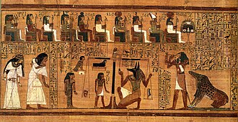
The weighing of the heart Papyrus 1250 BC Tomb of Ani.
We see a scale with the (alleged) internal organ jars on the left, a zeroing out “tare” to the right of the center pivot on the crossbar, and then the calibrated ostrich feather on the right. Maat was the holder of the calibrated ostrich feather. There is a scribe on the right keeping a record.

According to the Bible, Israelites settled in Egypt with the Exodus occurring roughly 1350 BC.
Hosea 6.2 was likely written between 755 and 725 B.C so, maybe 600 years later and is stated like it was common knowledge.

If we have “accuracy” on a scale, then something is being measured. From the introduction of “Book of the Dead” ({“11. In the formula , šes is “the measuring line used by builders,” and em šes signifies ‘ad amussim,’ ‘nach der Schnur,’ ‘au cordeau,’ ‘according to the line,’ hence ‘with the strictest accuracy.'Hibbert Lectures, 1879, p. 121. ‘According to the line of Maāt’ means ‘with undeviating regularity.'"

There are many “plates” in the book of the dead. (The text mentions taking a tracing from the carvings in the walls.) Many use the scale, and before that there was a boat. Around plate CXXIII there was a change, and it looks like a record of the Pharos history, how they are good by their gods, Osiris being the jackal, and in the above scroll we see what looks like jackal heads in this scroll from the British Museum. The original book of the dead from the "Society of Biblical Archaeology 1904” (link below)
Sir P. LE PAGE RENOUF, Knt.
CONTINUED AND COMPLETED BY
Prof. E. NAVILLE, D.C.L., &c., &c.,
Professor of Egyptology at the University of Geneva.

I said too much about this test because Egyptian belief is not the point. I want the reader to go away with the idea that if there was someone measuring it, then there was something to measure.

- Soul Substance Testing: Five physicians, led by MacDougall, constructed apparatuses to detect sudden force losses at death, reporting abrupt decreases.
  - Six human subjects. were used to create the 1901 page 52 cite “Soul Substance” report recorded by American Medical in the 1907 index.
  - 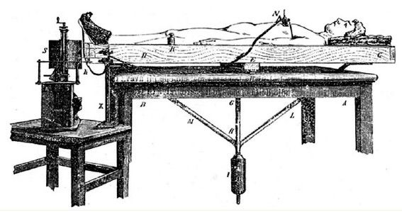
  - Each individual tested revealed different results of less than an ounce; this is consistent with an ostrich feather’s force against the scale in Egyptian tests.

- Imaging Attempts:
  - No mass was detected leaving the bodies at the time of the scale movement, indicating these were forces outside of the mass.
  - Multiple efforts to photograph the event continued for the rest of his life, indicating persistent belief among researchers.
  - 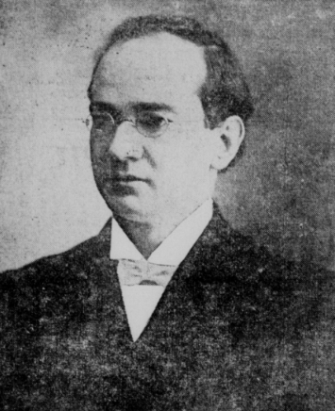
Dr. MacDougall
- Dog Testing: Identical weighing procedures on dogs yielded zero change.
5.3 Animal Testing and Philosophical Arguments
- Animals and Souls:
  - Debate persists over whether animals possess souls.
  - Did the dogs tested ever harm a human?
  - Plants, powered by hydrogen and releasing oxygen, are seen as fundamentally different from animals.
- Aquinas's Proof:
  - Aquinas argued that minerals and non-living matter lack love and desire, which are unique to living beings, supporting the concept of a separate, non-material function (the soul).
  - Minerals only react to outside forces.
  - Do dogs have true love and desire?
- Chemical Reactions: By definition, chemical reactions are externally triggered and not self-guided—supporting the idea that life requires more than chemistry.

5.4 Evolution, Creation, and Fabricated Claims
- There have been false claims of creating life in laboratories, but these often amount to modifying already-living organisms, not generating life from nonlife. Artificial modifications do not equal true creation.
- Venter Testing: Raises concerns about the authenticity of artificially modified life forms.
  - Does a man with an artificial leg and eye make a new creation? What about algae that has been altered? It is a damaged version of the original.
  - Are children who are told there is no additional content in them but minerals more or less likely to think life is cheap?
- The cost of false claims includes widespread demoralization and misinformation across generations.
- Social and Media Responses: Media reports, including those from social workers, often offer unqualified denials without direct investigation.

6. Addressing the Potential for Fraud and Error
- Could evolutionists fake tests to disprove the soul? Considerations include:
  - Testing between heartbeats versus after prolonged death.
  - Personal belief that humans are composed of three elements: soul, spirit, and minerals.

7. Scriptural Foundations
- Hosea 6:2 (NIV): "After two days he will revive us; on the third day he will restore us, that we may live in his presence." This aligns scriptural patterns with reported experimental intervals.
- Role of Jesus: Restoration on the third day is uniquely attributed to Jesus, reinforcing the theological claim.
- Lazarus, on the fourth day, one day past the third day, and we have Lazarus Testimony. (John 11:17, Luke 16:23) Jesus knowingly leaving his friend Lazarus through the fourth day so he could testify for us today. Where did Lazarus go when he saw Abraham?

- This further supports the third day and the transition point. We have a fourth day resurrection and testimony in the Bible from a Lazarus who was a witness describing in my engineering mind a time trap where an unending time dilation separates the clustered souls in this situation, built into the construction of the universe. (Do you want to know why I think this? Read “Evolution is a Law Against Religion” to get the complete studies on the data provided by the Bible.)

8. Comprehensive Summary of Qualitative Data
Human Subjects
Abrupt loss at death (less than one ounce), with no visible mass change.
Loss is directional (downward) and not visible.
The description fits a force.

Animal Subjects
Dogs: No measurable change, possibly indicating lack of a soul or complete moral innocence.
Timing
Three-day interval: Observed in both scriptural and experimental records (e.g., Lazarus, Jesus, Egyptian rituals).
Historical and Experimental Apparatus
Ancient Egyptian Equipment: Scales, calibrated feather and organ containers for testing.
20th Century Physicians: Custom weighing platforms, fluid capture systems, and varied imaging systems.
Imaging: No reproducible visual evidence, suggesting the force is something other than a mass.

9. Discussion: Can evolution create theories or animals?
- The data indicate a sudden, directional force change at death, most consistently measured downward and described as abrupt.
- The three-day pattern is robust across ancient, scriptural, and modern accounts.
- Biological Arguments: Life has not been produced from minerals, and genetic manipulation requires pre-existing living material.
- Reactions vs. Desire: Chemical reactions are not self-motivated, distinguishing living beings from nonliving matter. This proves there is something else inside us we call a soul*. This soul provides functions minerals do not have.
- Limitations: Experimental data are limited in quantity, scope, and reproducibility. Most sources are qualitative, with failed attempts at imaging and single-axis (downward) measurements.

10. Broader Implications and Societal Critique
- Governmental and Institutional Motives: Governments and schools promote evolution, possibly for control rather than scientific merit.
- Attack on Tests: The soul substance testing was criticized by both church and secular authorities, suggesting it was not mere religious propaganda. This was divine providence adding validity to the claim similar to the Jews crucifying Jesus and not wanting it to happen.
- Lack of Contradictory Evidence: Most opposition is speculative or dismissive rather than based on direct experimentation.
- Wider Social Trends: Feminist and governmental ideologies are critiqued for undermining traditional concepts of the soul and the distinction between men and women.
- Religious Distinctions: Differences between Christian, Muslim, and secular views on the afterlife and the soul are noted.

11. Mathematical and Philosophical Confidence
8. Conclusion
While historical, scriptural, and early experimental sources documented a measurable event at death. The recurring three-day interval warrants further investigation. Modern instrumentation could help define the force change or detectable phenomenon that occurs at death or within the proposed temporal window.
We would be hard pressed to claim the test results from several different sets of testing to all be falsified in the same way. Testing is the way we discover the rules of this world.
Claims by evolution have failed repeatedly for ages.

The power that is not accounted for inside us
The one spirit (1 Corinthians 12:11): All these are the work of one and the same Spirit, who apportions them to each one as He determines.
The expected lake of fire was the result for every human tested.

- Jesus has promised to raise you up. Rising of this force without external or later intervention without Jesus is not possible (There is one way to salvation: Jesus).

The separating or plucking apart (your separate body and your inner self) and living in the presence on the third day.
No other name has documented the ability to raise you up on the last day.

We expect there to be the trip to hell, we expect the soul to have an afterlife, and we know that Jesus will raise us up, so the pieces of the puzzle fit this system.
We have disclaimers from sources that have never done the investigation.
I do not see the soul-substance test as a made-up religion claim because the church was attacking them. I do not see the Egyptian testing to be related to Jesus because of the dog heads in the “Book of the Dead."There is no mention of Jesus in the works.
The soul Substance testing was attacked by the church so we know it was not church propaganda.
In all my studies there was a lack of contrary information contradicting the tests. There was speculation and hearsay by some basic naysayers and social workers.
The Bible says that governments are against us and municipalities. The feminists must have no historical truth since they must have no difference between man and woman, and this extends into their gender damage to children. The Muslims do not have the concept of the soul going to hell and being rescued by God as Jesus the Christ. The government has an interest in control, reinforcing control, deals for the growth of government, and alliances.
Taking power away if it was understood that God was our controller and owner diminishes that control to tolerating them.

Can evolution create animals or theories or a law against religion?
Considering that so many animals have died off extinct and zero animals created by the evolution belief system, it is difficult to have faith in its validity. We can see the real curve of the running down of the system of things in “Evolution is a Law Against Religion."
Let us do the reality test by looking at real life. We can make a confidence ratio of the expected confidence that God made everything and it is deteriorating versus the evolution belief system when calculated through time. We express this as a percentage of confidence. The mathematics of 1000000000 extinctions divided by zero creations for evolution in our entire existence, and anything divided by zero is infinity. So it is infinitely NO on evolution and infinitely YES on JESUS. Therefore, it is much easier to have faith in the existence of Jesus Christ.
Evolution can create theories but has never created animals.
We do not need to count the exact number of extinctions since any number divided by zero is still infinity; whether we have a million infinities or just one infinity, it is still infinity.

- Reality Test: If evolution predicts creation of new species, but only extinctions are observed (e.g., 1,000,000,000 extinctions and zero creations), then mathematically, confidence in evolution is infinitely low and confidence in creation is infinitely high.
- Faith in Jesus: The argument concludes that evidence and mathematics make faith in the resurrection and Jesus more reasonable than belief in evolution.

12. Conclusion
What happened to those tested and their eventual descent into Hell was a result of things they did to themselves and perhaps preordained by the construction of the system of things that we put ourselves into at the time of Adam and Eve.
While historical, scriptural, and experimental sources document a measurable event at death, the recurrence of the three-day interval and consistent directionality of force change warrant further investigation. The data not only challenges evolutionary narratives but also bolsters the possibility of a non-material soul, carrying significant philosophical, theological, and societal implications. Future research using modern technology may clarify these mysterious phenomena. 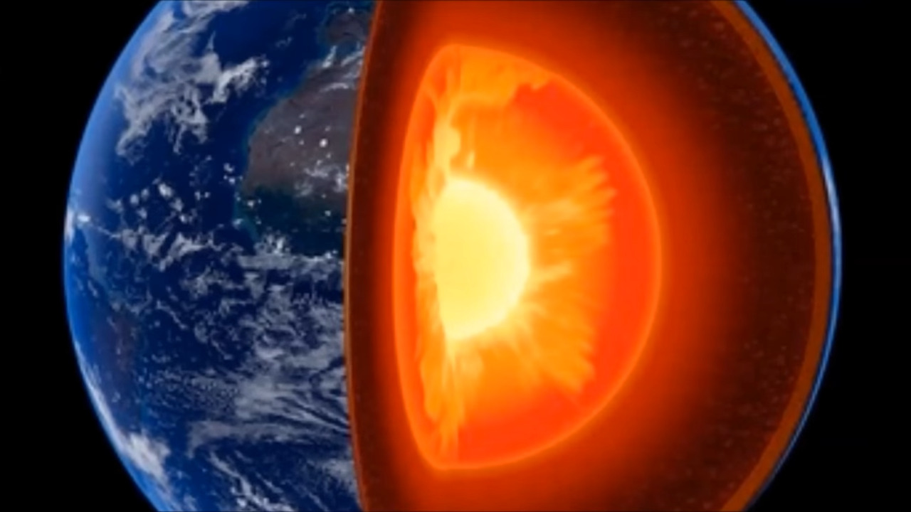

Realistically, the tested souls must have ended up in the center of the magma. (Lake of Fire (Hell)) Romans 3:23: "For all have sinned and fall short of the glory of God."

References
- Ancient Egyptian funerary texts (Book of the Dead)
- The Holy Bible (e.g., Hosea 6:2, 1 Corinthians 12:11)
- MacDougall, D. (1907). Soul Substance Report,
- "American Medical" Index from 1907
- Author’s book: Evolution Is a Law Against Religion
- Social worker citations and media reports
- Philosophical writings (Aquinas)
\
* We use “soul” for a more complicated construct that is too big for this teaser. This substance might even be called a type wisdom because of the inherent understanding of how to make a child and a power to make it function with our own essence, our thoughts and ideas.
© 2026 Douglas A. Huebner. You are welcome to download and share this manuscript for personal, noncommercial use. Please keep the author’s name and copyright notice with it.

